1 ) Create a Database
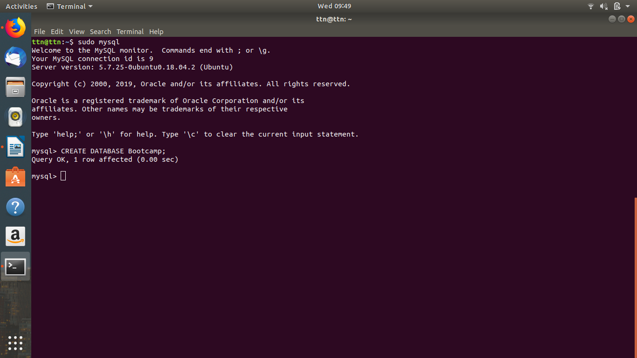

Query Used : CREATE DATABASE <DATABASE_NAME> ;

2) Design Schema
Problem Statement: There can be multiple customers, who can place multiple orders on the site. Now a sales person can handle these orders will distribute into multiple sales persons (One order will be assign to one salesperson only). So a sales person can have multiple orders of multiple customers

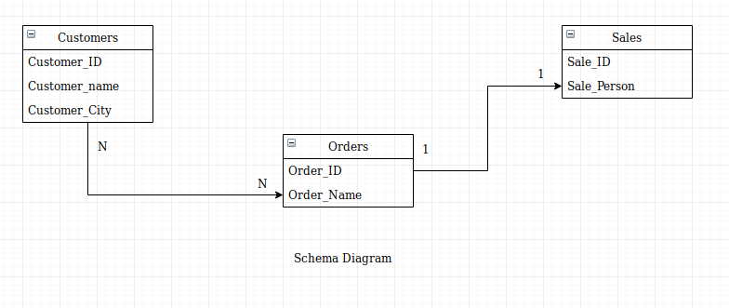

3 ) Create tables
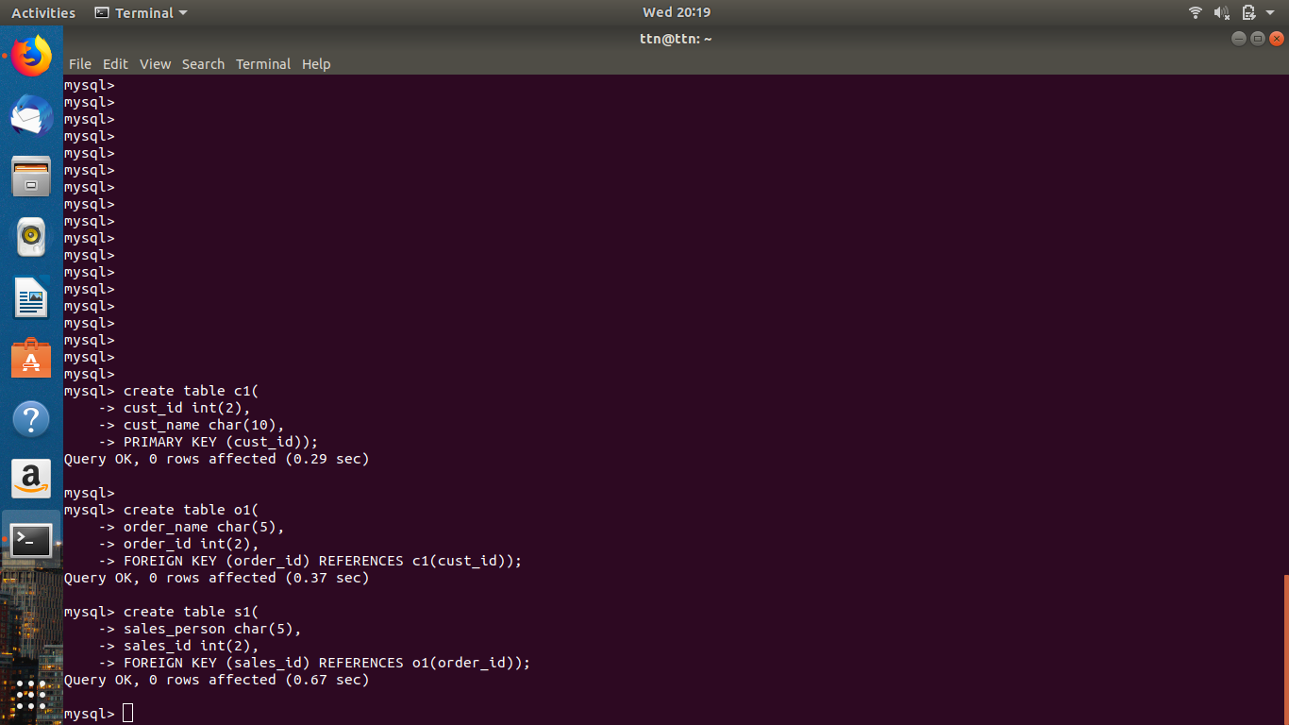

Query Used: Create table Sales (
id int(6) PRIMARY KEY,
name char(20) NOT NULL,
email varchar(50),
soldunits int(5));

4) Insert sample data

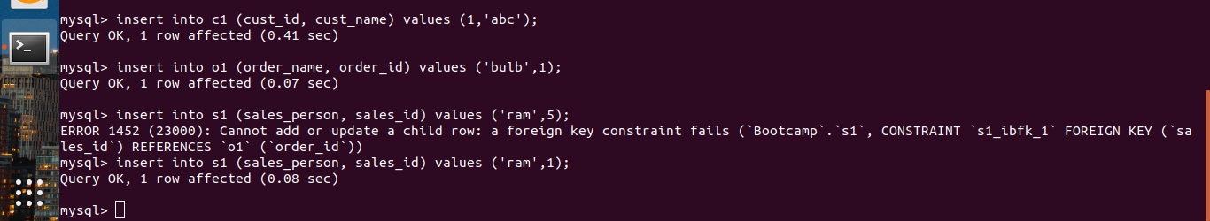

Query Used:
Insert into sales (id, name, email, soldunits) values (1,’abc’,abc@gmail.com’,50);

5) Find the sales person have multiple orders.
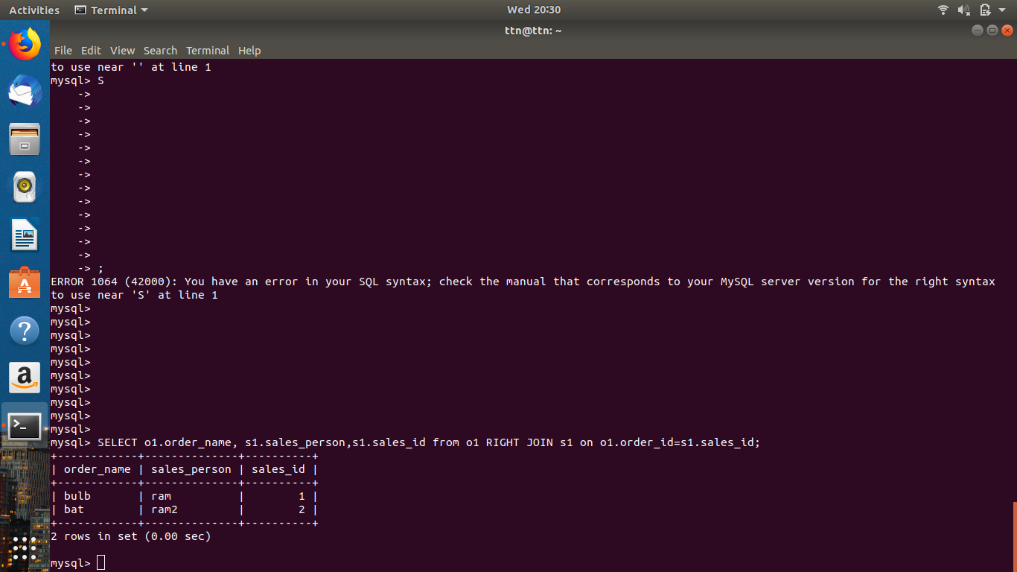

6)Find the all sales person details along with order details

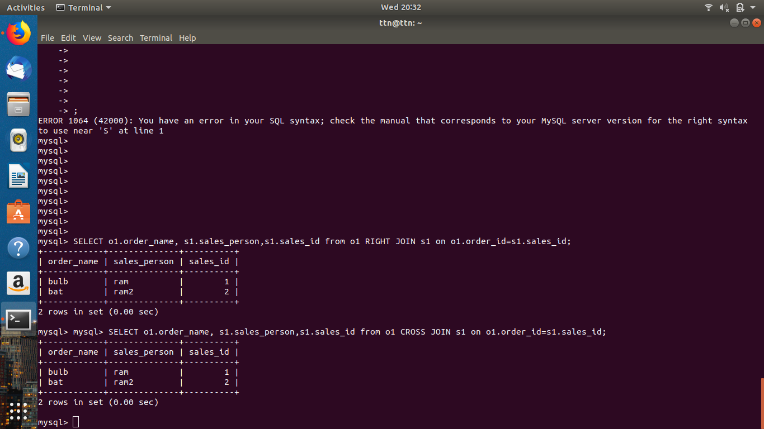
Used join to get the required results.

7) Create index
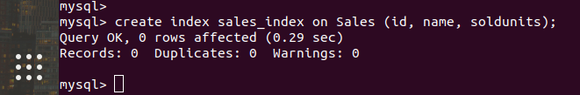

Query Used: create index <INDEX_NAME> on <TABLE_NAME> (column1, column2,);

8) How to show index on a table

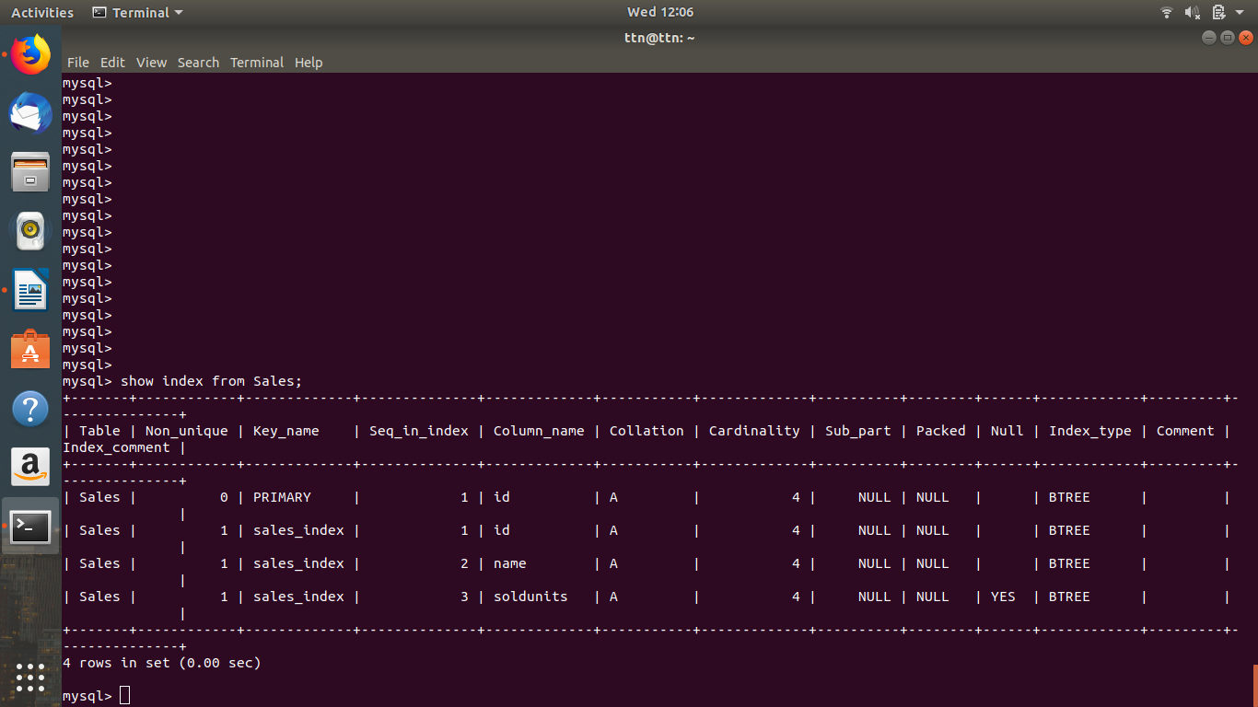

Query Used: show index from <TABLE_NAME>;

9) Find the order number, sale person name, along with the customer to whom that order belongs to

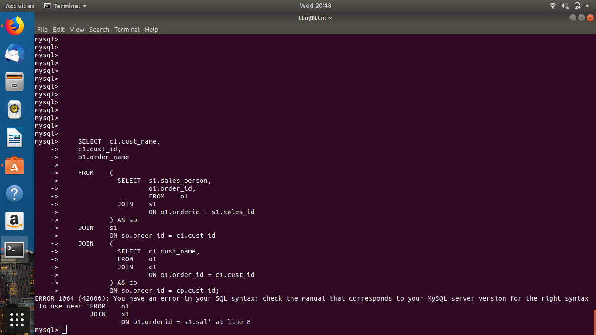
Solution requires us to join three tables so nested joins will work here for us. This throws an error.
Query:

SELECT c1.cust_name,
c1.cust_id,
o1.order_name

FROM (
SELECT s1.sales_person,
o1.order_id,
FROM o1
JOIN s1
ON o1.orderid = s1.sales_id
) AS so
JOIN s1
ON so.order_id = c1.cust_id
JOIN (
SELECT c1.cust_name,
FROM o1
JOIN c1
ON o1.order_id = c1.cust_id
) AS cp
ON so.order_id = cp.cust_id;

TABLES

c1
cust _name, cust_id

o1
Order_name, order_id
S1
Sales_person, sales_id
c1-------------------N to N Relation --------------------------------------------o1
o1-------------------N to 1 Relation ---------------------------------------------s1

